1 БД 1

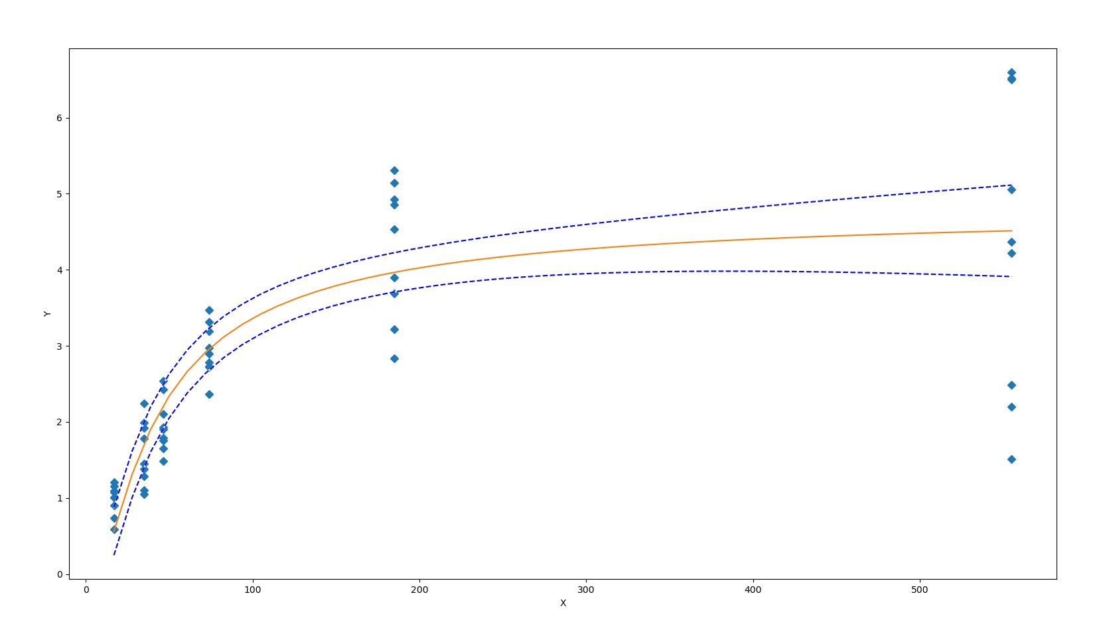A = 4.8631167712833214E+00 B = 1.5358136969061279E-03 K = 3.6209638804175256E+01

Solutions for f'(x)=0: [18105.0]

Solutions for f''(x)=0: [18.077887683431914, 36191.922112316555]

Solutions for f'''(x)=0: []

1 БД 7

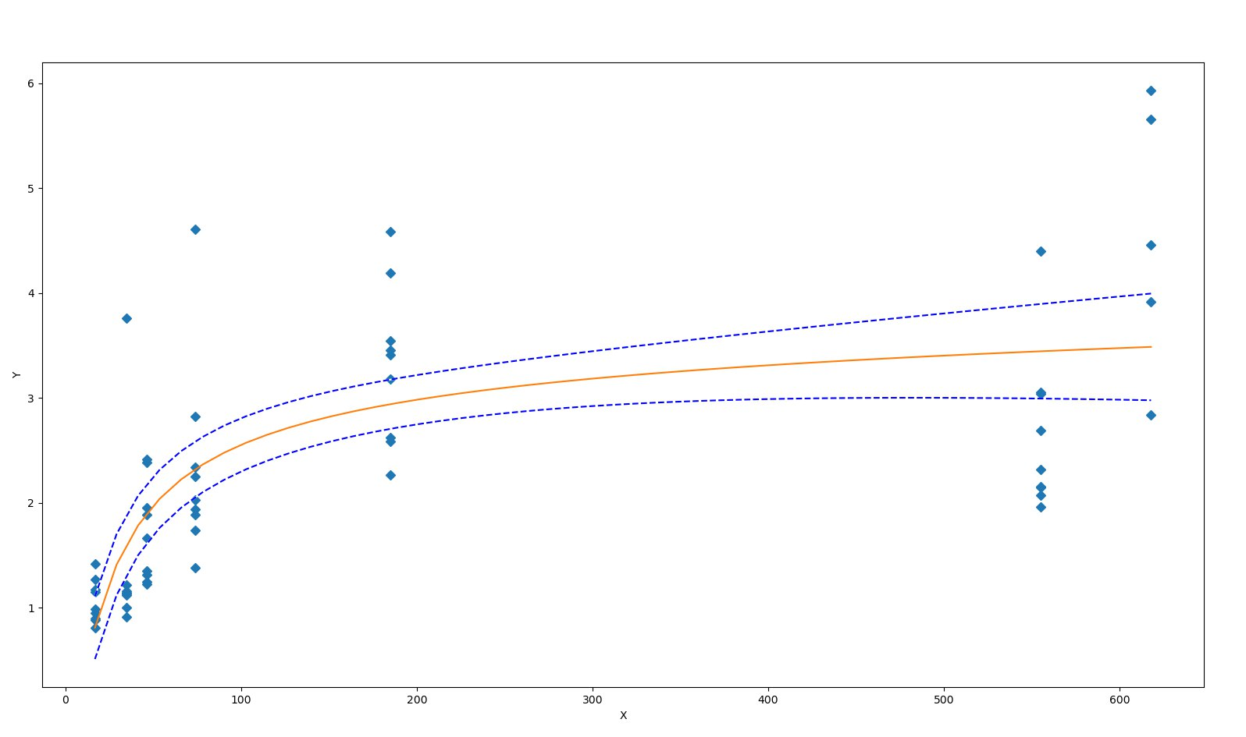A = 2.1957857367487481E+00 B = -7.7057744414509771E-02 K = 2.0475678248793351E+01

Solutions for f'(x)=0: [- 265.9220779220779]

Solutions for f''(x)=0: [- 542.7140852215476, 10.869929377393653]

Solutions for f'''(x)=0: []

1 БД 14

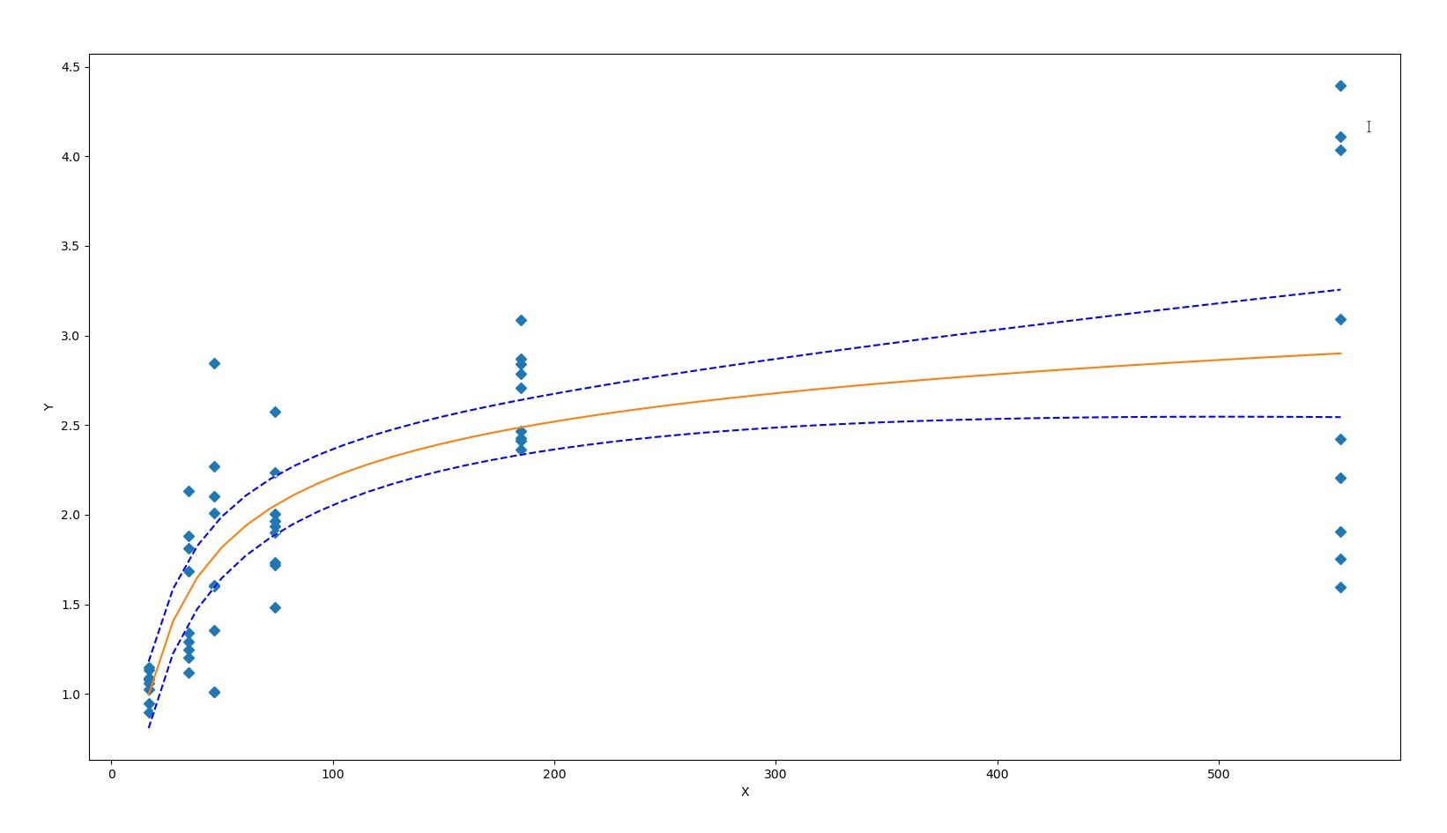A = 1.5941118342314649E+00 B = -9.8293968850580310E-02 K = 1.2608324863793108E+01

Solutions for f'(x)=0: [- 128.6530612244898]

Solutions for f''(x)=0: [- 264.1148654418032, 6.808742992823322]

Solutions for f'''(x)=0: []

1 БД 21

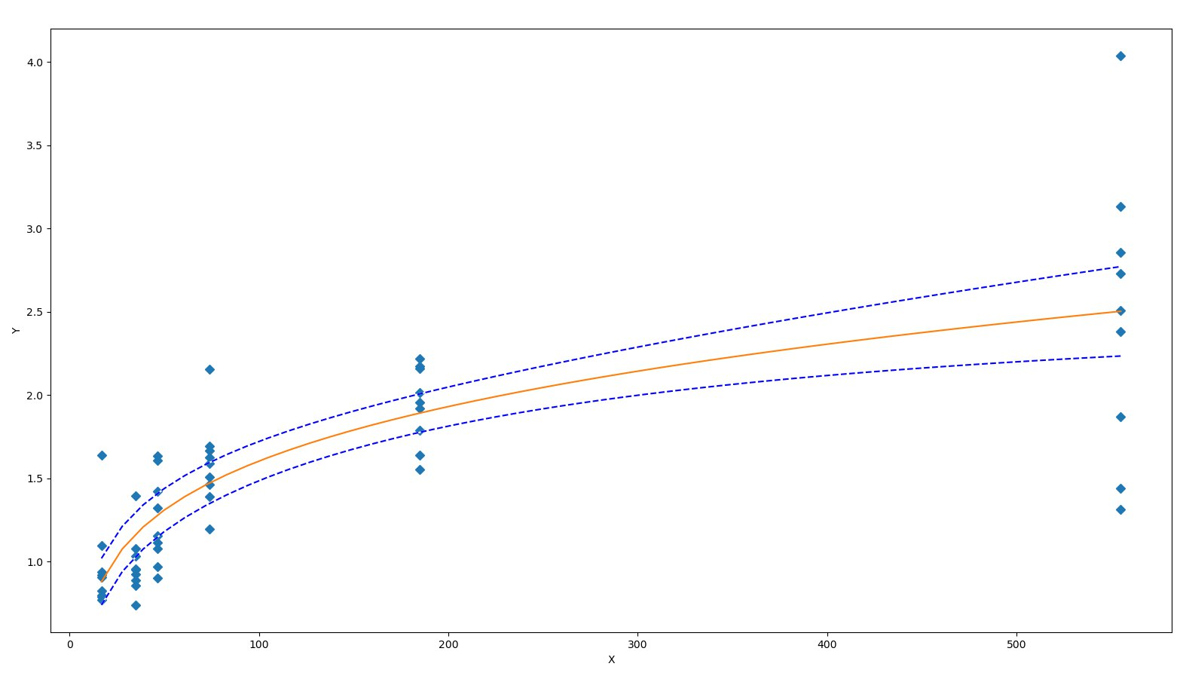A = 5.4057786358925686E-01 B = -2.4350295704594371E-01 K = 3.3494766302941952E+00

Solutions for f'(x)=0: [- 13.725409836065573]

Solutions for f''(x)=0: [- 29.511130862278296, 2.06031119014716]

Solutions for f'''(x)=0: [- 45.26277268202559, 0.773222968183407, 3.3133202056454483]

1 БД 30

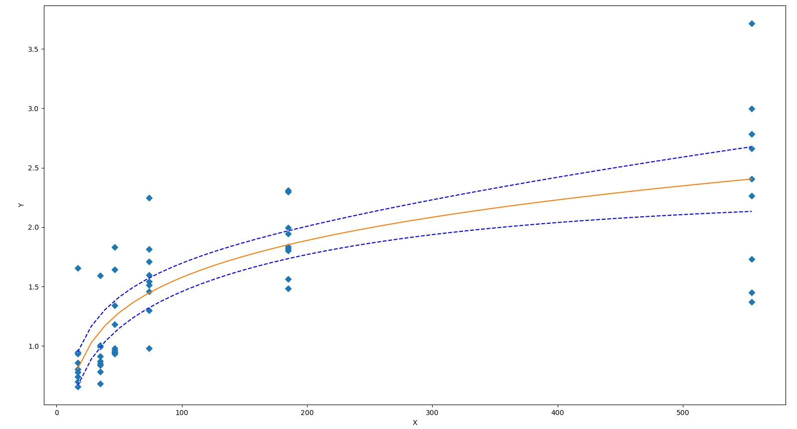A = 6.0834205874735692E-01 B = -2.1913674741485478E-01 K = 5.6688524471316368E+00

Solutions for f'(x)=0: [- 25.885844748858446]

Solutions for f''(x)=0: [- 55.177021886043406, 3.4053323883265567]

Solutions for f'''(x)=0: []

2 БД 1

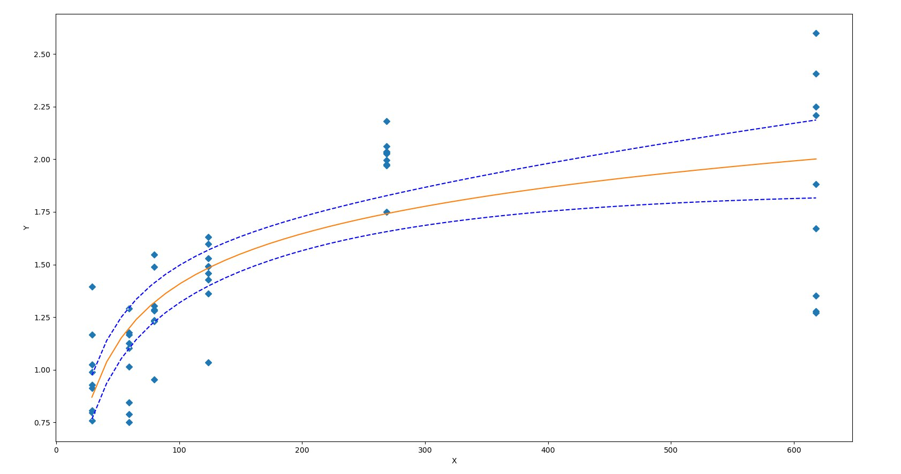A = 8.6130972426327723E-01 B = -1.3441929037783909E-01 K = 1.2873256172416571E+01

Solutions for f'(x)=0: [- 96.06716417910448]

Solutions for f''(x)=0: [- 199.29956435003902, 7.165235991830136]

Solutions for f'''(x)=0: []

2 БД 7

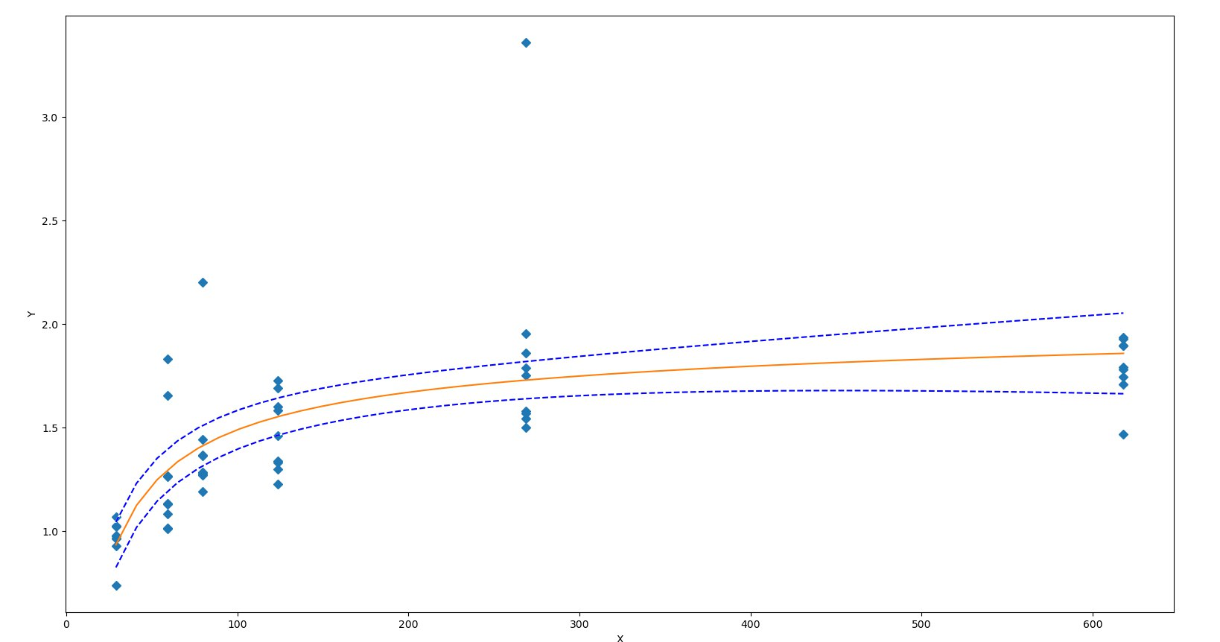A = 1.4413858594793623E+00 B = -4.3856073427921291E-02 K = 1.6853152121265623E+01

Solutions for f'(x)=0: [- 383.02272727272725]

Solutions for f''(x)=0: [- 774.760633857576, 8.715179312120702]

Solutions for f'''(x)=0: []

2 БД 14

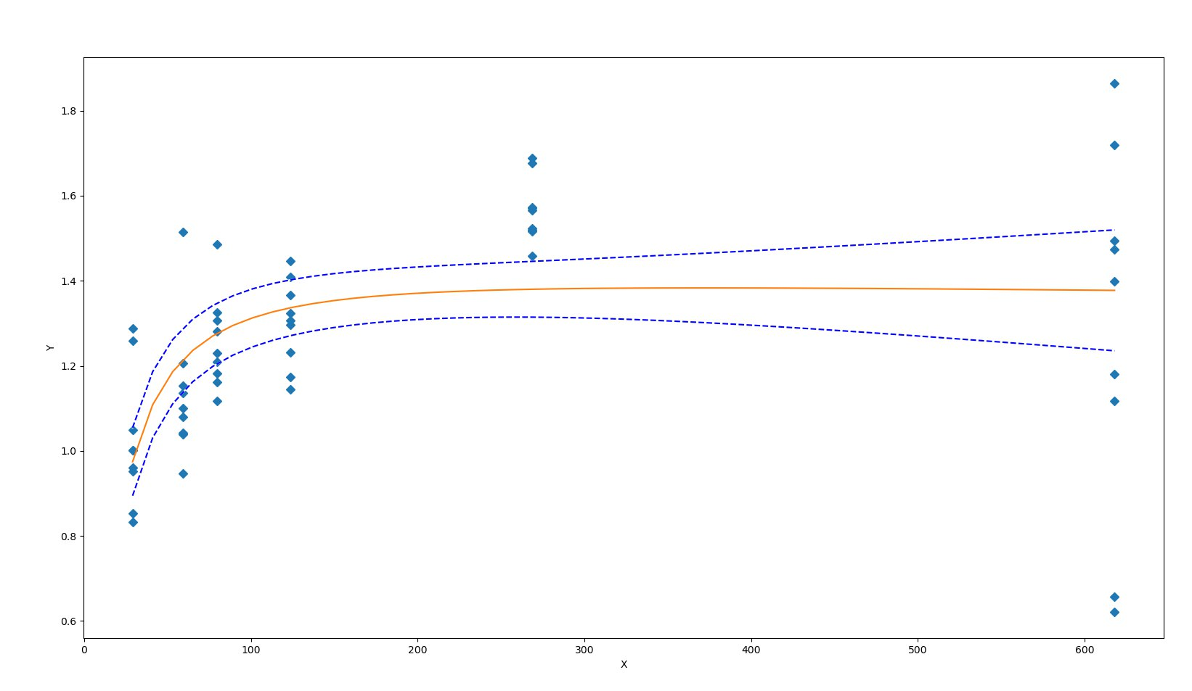A = 1.7970675304299131E+00 B = 3.7839161788830511E-02 K = 1.4077379123035673E+01

Solutions for f'(x)=0: [370.44736842105266]

Solutions for f''(x)=0: [6.844050764474998, 734.0506860776297]

Solutions for f'''(x)=0: []

2 БД 21

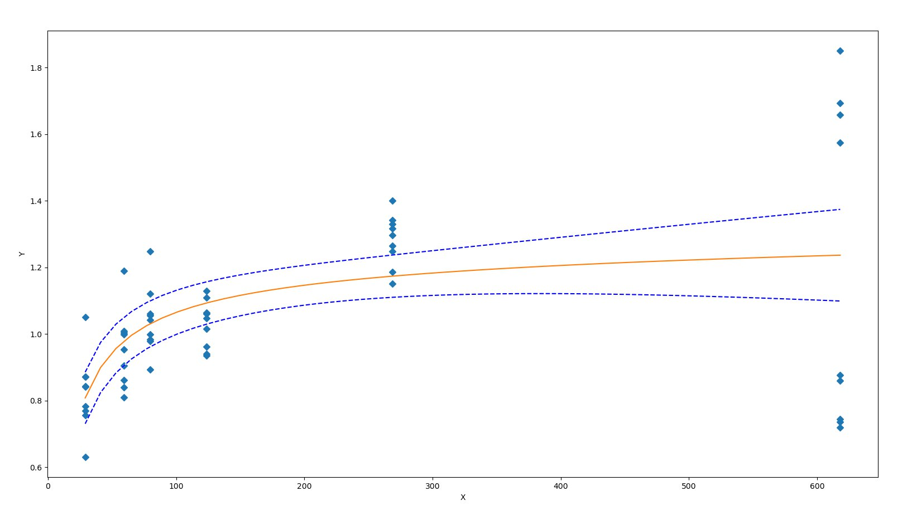A = 9.7582115528010960E-01 B = -3.9195557804166746E-02 K = 9.3195336075932715E+00

Solutions for f'(x)=0: [- 238.97435897435898]

Solutions for f''(x)=0: [- 482.7496095348991, 4.800891586181173]

Solutions for f'''(x)=0: []

2 БД 30

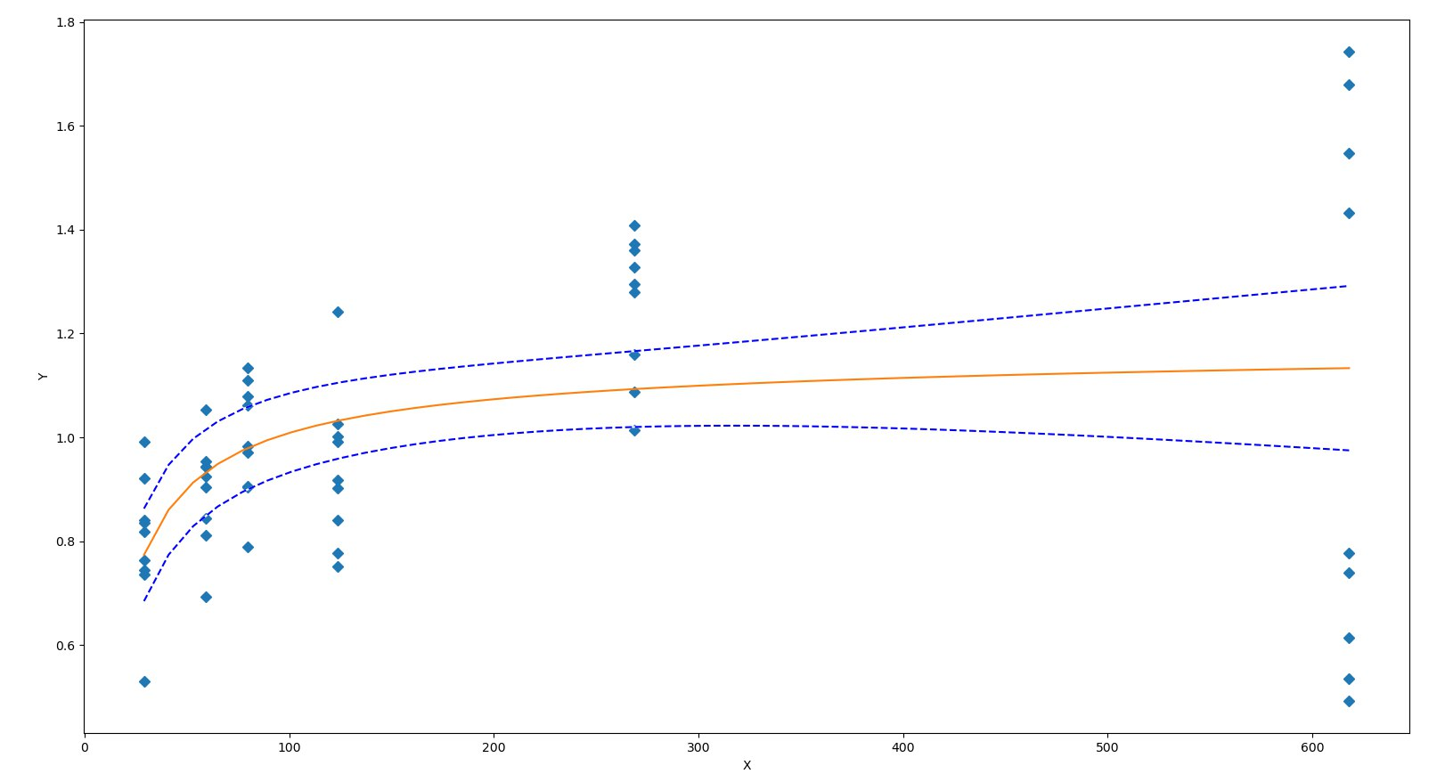A = 1.0233302001028319E+00 B = -1.8380400132834308E-02 K = 9.9295975118177076E+00

Solutions for f'(x)=0: [- 551.6666666666666]

Solutions for f''(x)=0: [- 1108.3663823419174, 5.0330490085825685]

Solutions for f'''(x)=0: []

1 СИД 1

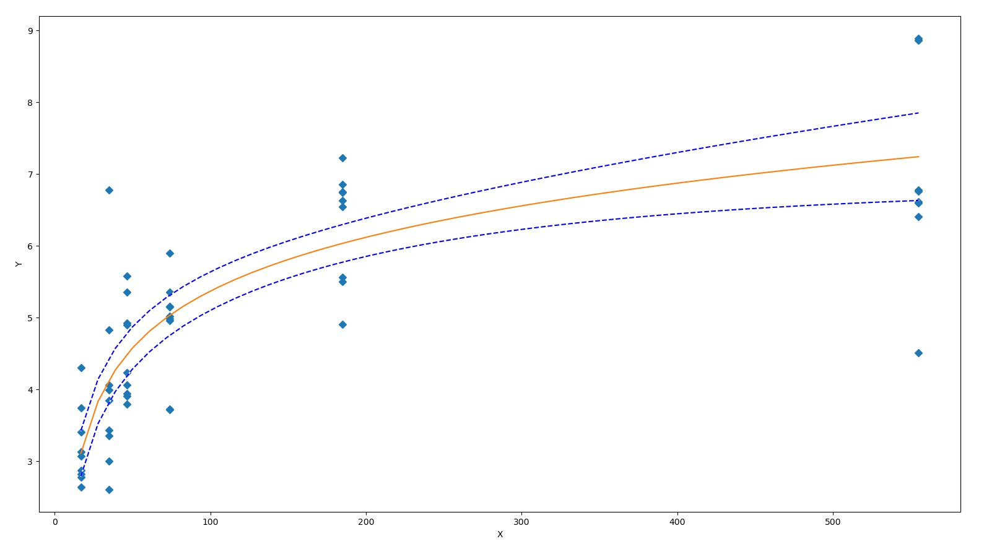A = 2.8903785880388044E+00 B = -1.4694933064453330E-01 K = 5.7455112041892331E+00

1 СИД 7

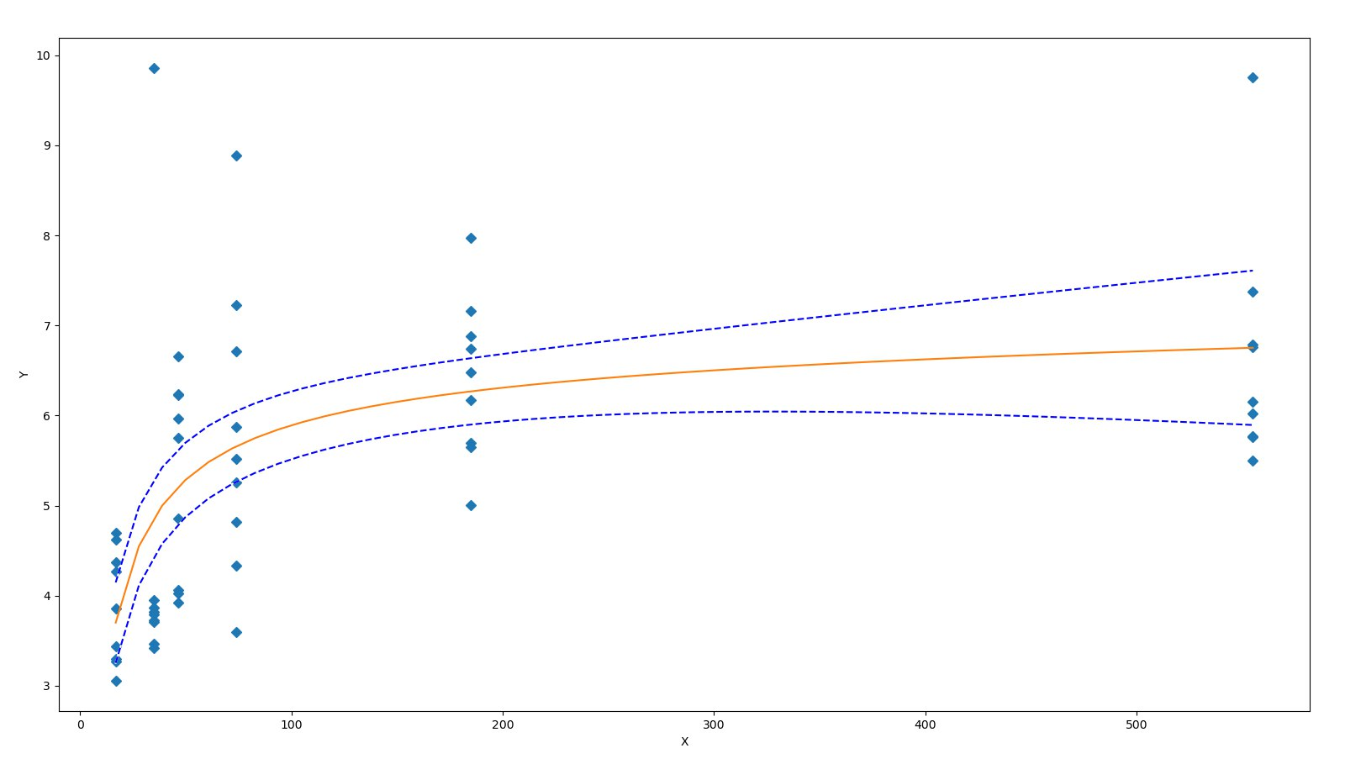A = 5.2600546798662835E+00 B = -4.1772670242971280E-02 K = 7.9006866319563125E+00

1 СИД 14

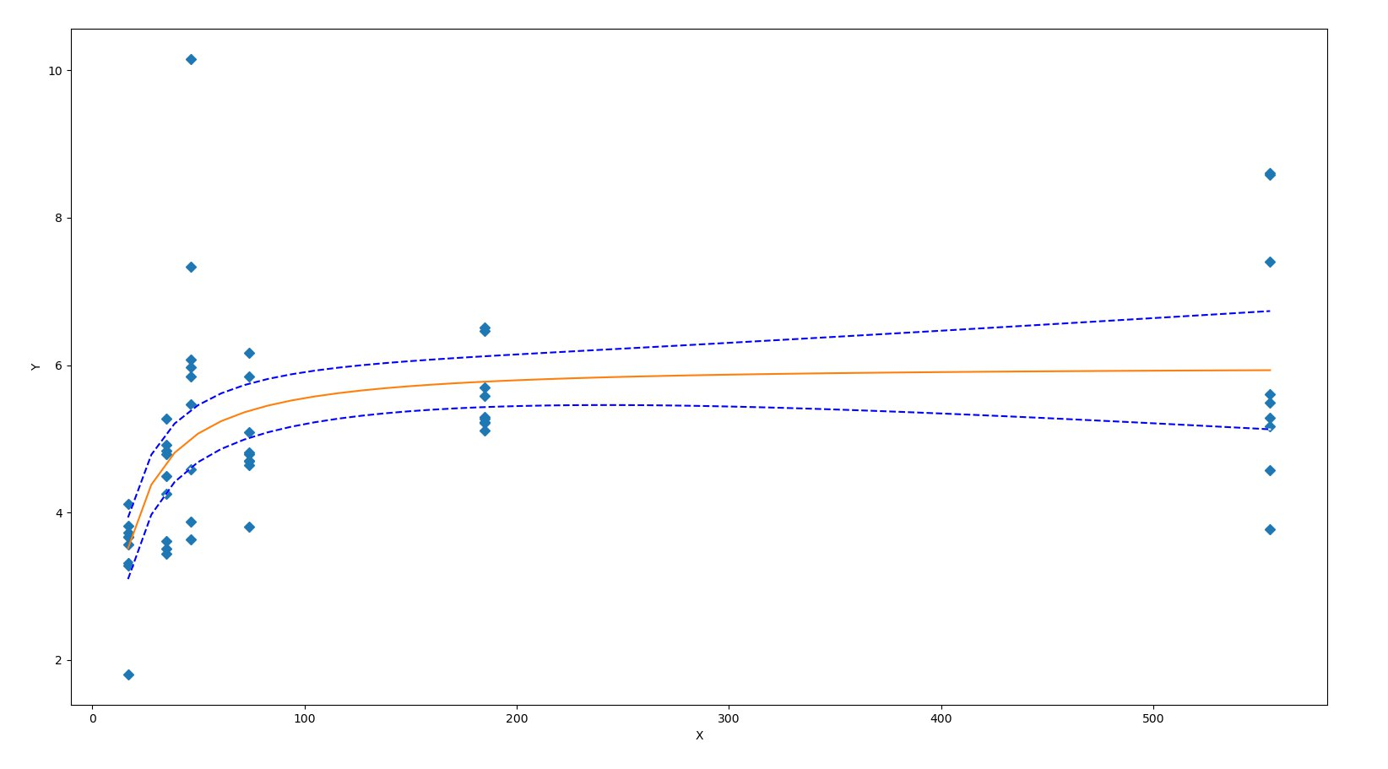A = 6.3037260673192321E+00 B = 6.9171546079976366E-03 K = 9.4907928849745442E+00

1 СИД 21

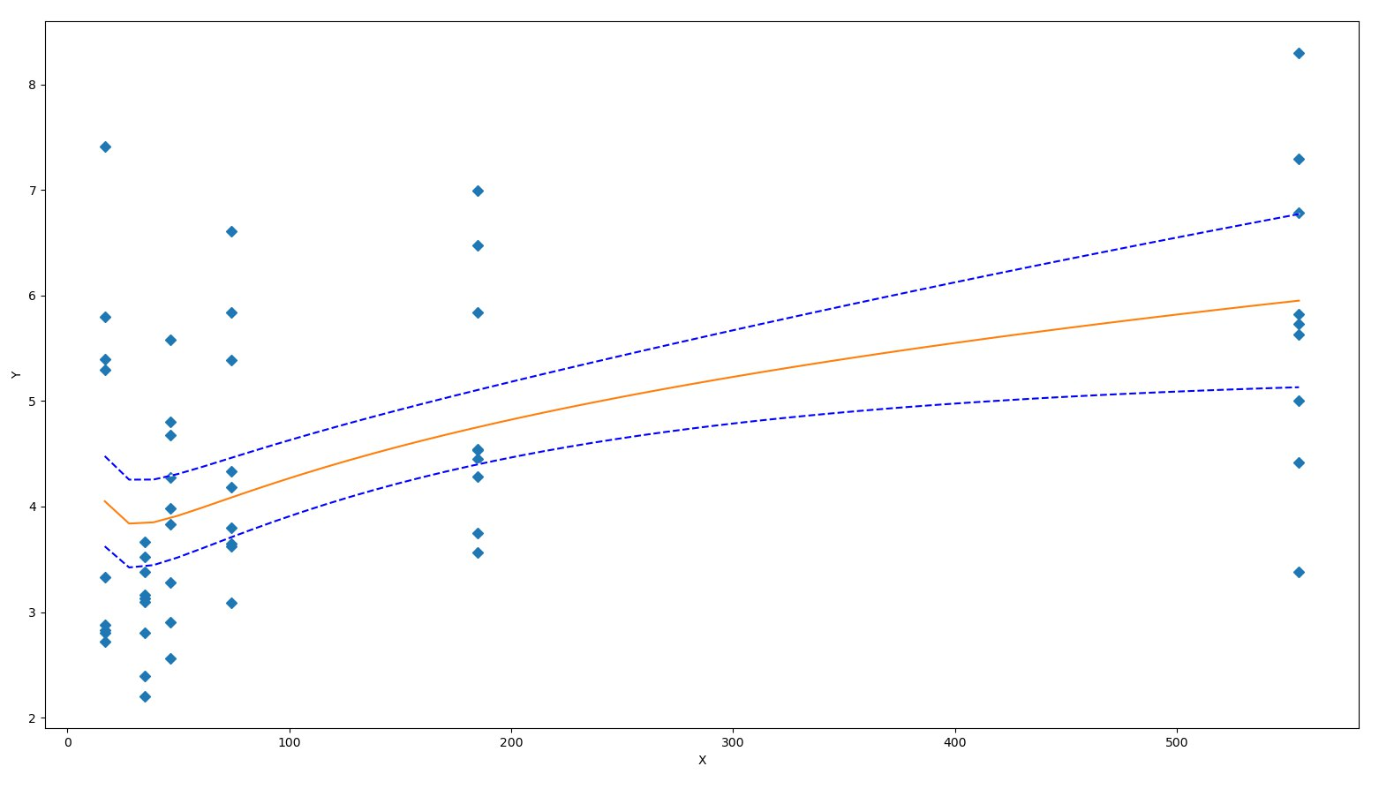A = 1.3895122023615460E+00 B = -2.2815834733194221E-01 K = -7.1644731483959738E+00

1 СИД 30

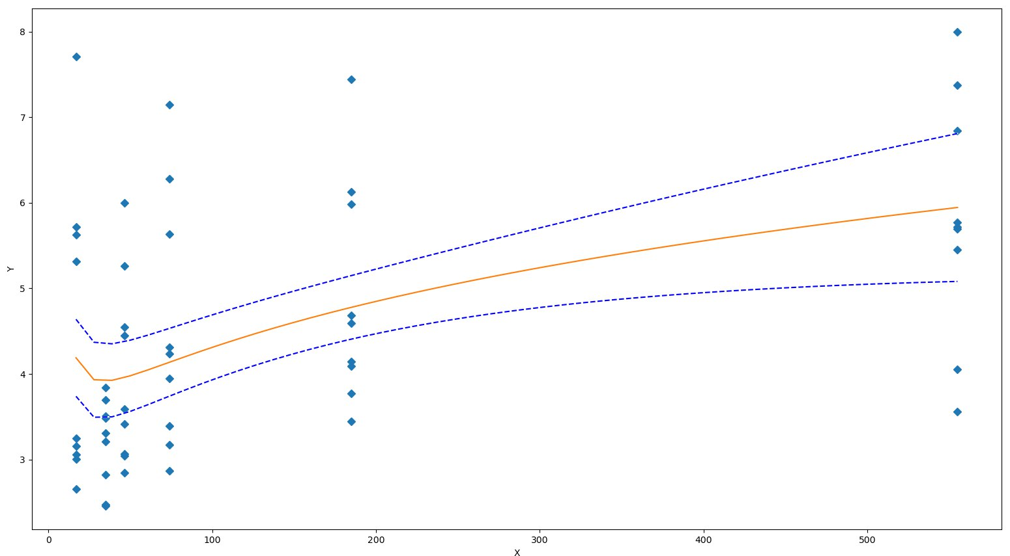A = 1.4302735288510244E+00 B = -2.2335056084850130E-01 K = -7.4697426668789282E+00

2 СИД 1

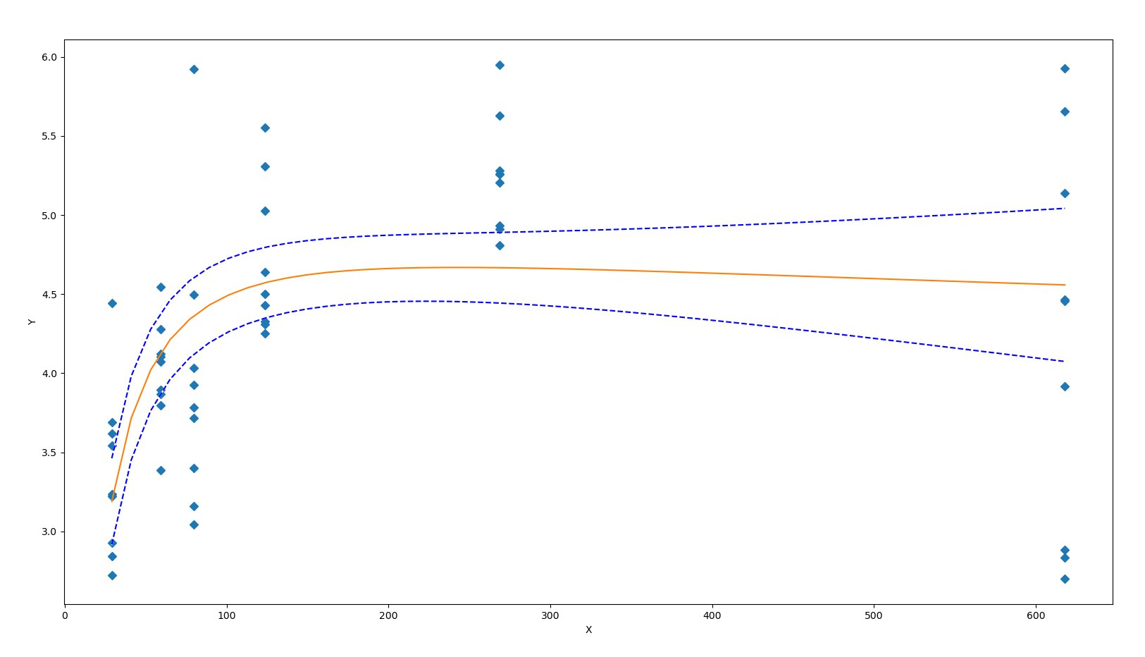A = 2.1957857367487481E+00 B = -7.7057744414509771E-02 K = 2.0475678248793351E+01

2 СИД 7

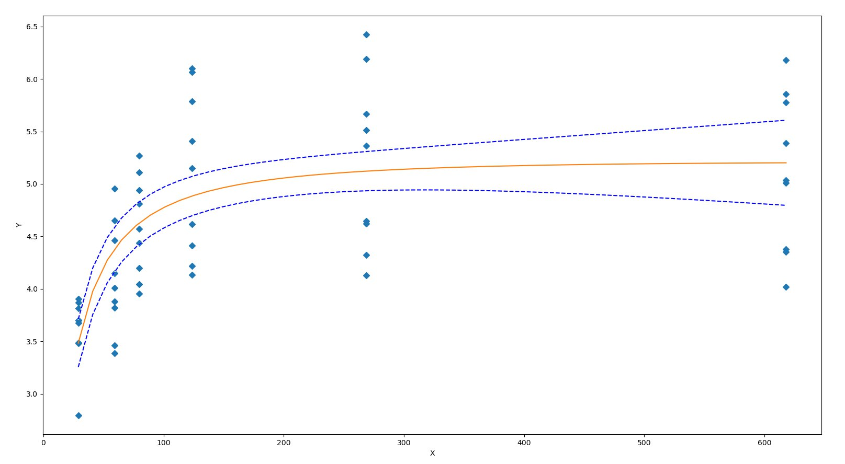A = 5.8979764760419169E+00 B = 1.6113805909230366E-02 K = 1.3727330781626364E+01

2 СИД 14

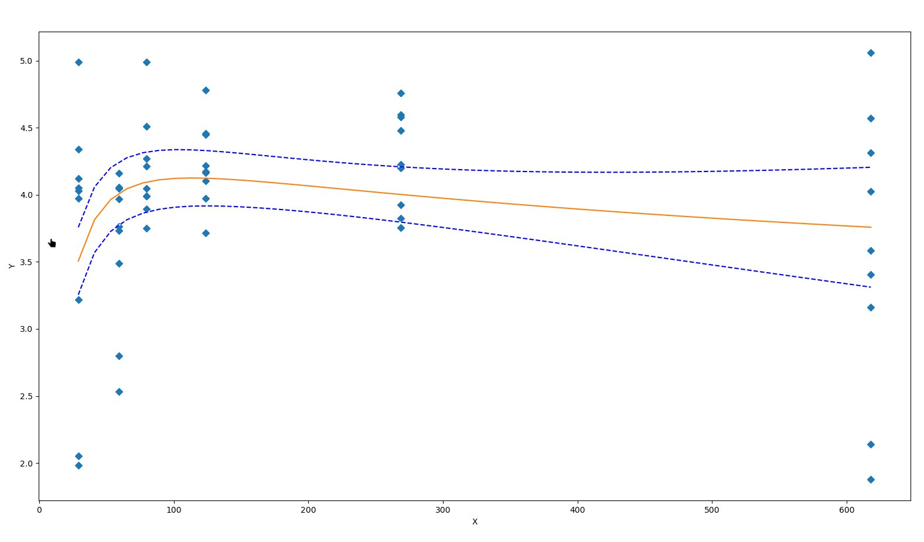A = 7.5657162954463937E+00 B = 1.0584720288844360E-01 K = 1.1983608940457195E+01

2 СИД 21

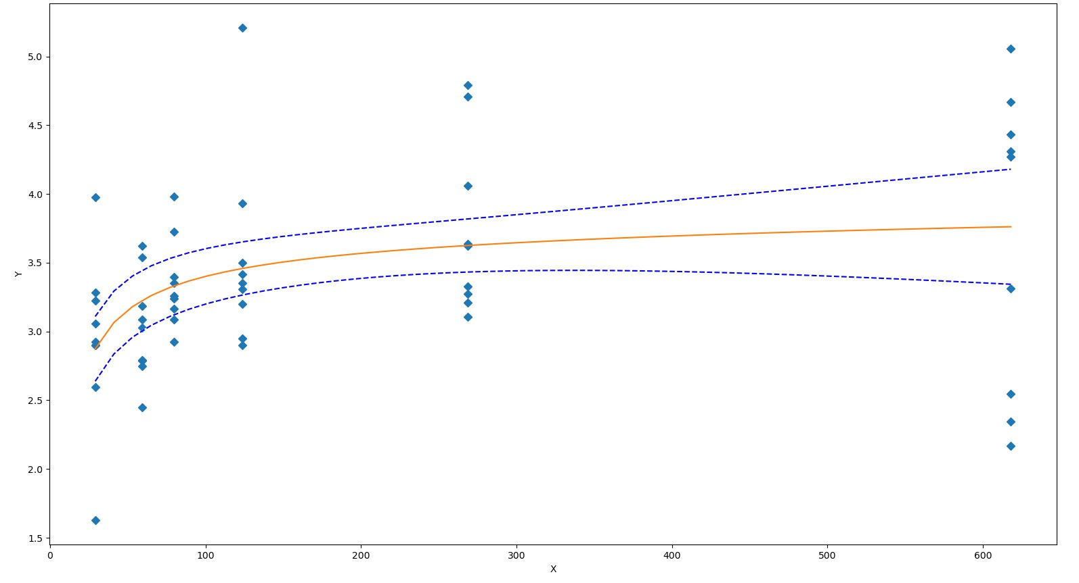A = 3.1118191976690506E+00 B = -3.0849499810562141E-02 K = 5.3343370426373511E+00

2 СИД 30

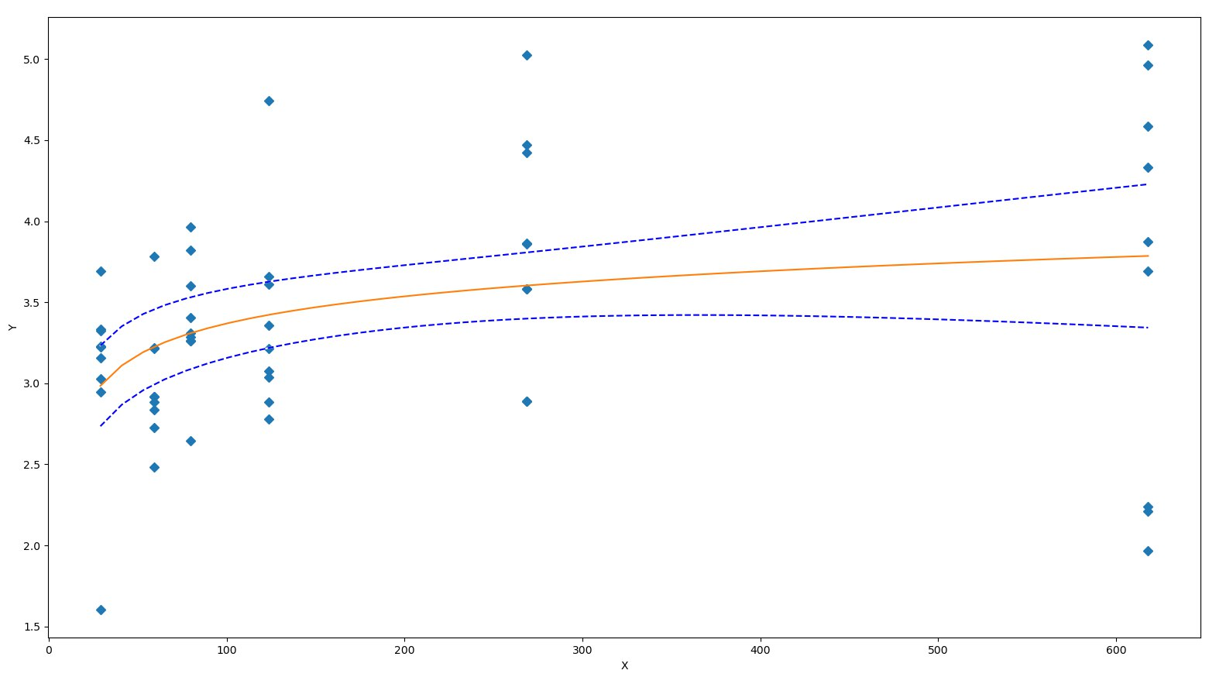A = 2.6917163075002941E+00 B = -5.3636485063044435E-02 K = 2.2512573412904633E+00